DBMS LAB Assignment-1

Name- KESHAV GARG

Id- 2018UCP1674

1. Customer Table in Database 2018ucp1674:

[CREATE](http://localhost/phpmyadmin/url.php?url=https://dev.mysql.com/doc/refman/5.5/en/insert.html" \t "mysql_doc) TABLE customer (cust\_id INTEGER PRIMARY KEY, cust\_name VARCHAR(25) ,city VARCHAR(25),country VARCHAR(24));

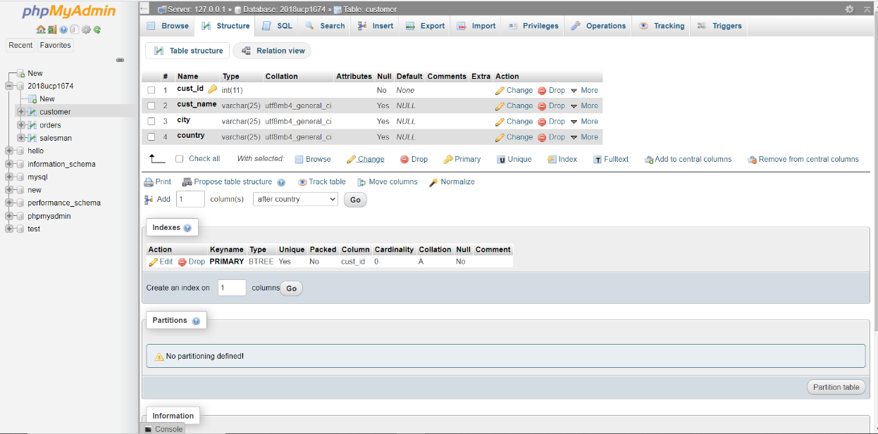

Orders Table in Database 2018ucp1674:

[CREATE](http://localhost/phpmyadmin/url.php?url=https://dev.mysql.com/doc/refman/5.5/en/insert.html) TABLE orders (ord\_no INTEGER PRIMARY KEY, pur\_amt INTEGER ,ord\_date INTEGER,cust\_id INTEGER, salesman\_id INTEGER)

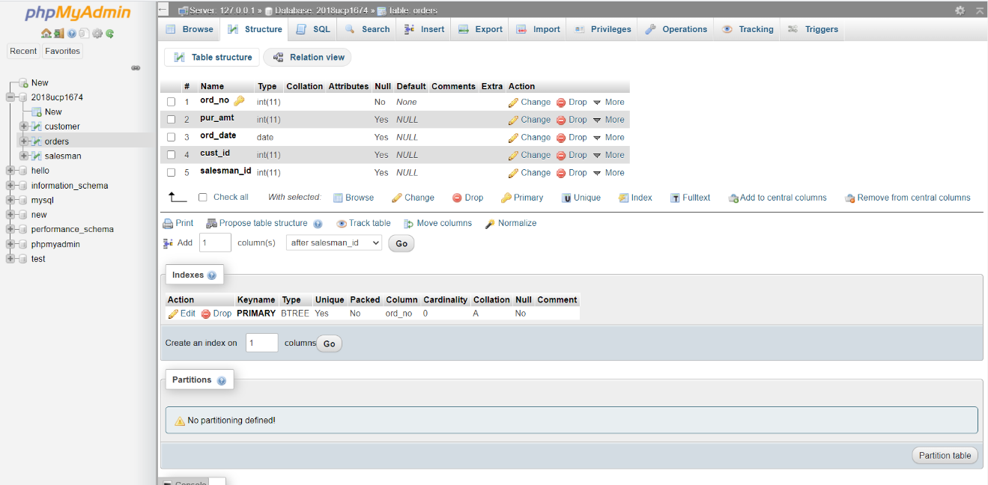

Salesman Table in Database 2018ucp1674:

[CREATE](http://localhost/phpmyadmin/url.php?url=https://dev.mysql.com/doc/refman/5.5/en/insert.html) TABLE salesman (salesman\_id INTEGER PRIMARY KEY, name VARCHAR(25) ,city VARCHAR(25), commission INTEGER)

1. Insert single row of data in the table Customer, Orders & Salesman.

[INSERT](http://localhost/phpmyadmin/url.php?url=https://dev.mysql.com/doc/refman/5.5/en/insert.html) INTO customer [VALUES](http://localhost/phpmyadmin/url.php?url=https://dev.mysql.com/doc/refman/5.5/en/miscellaneous-functions.html#function_values) (1,'Keshav Garg','Dhanbad','India');

[INSERT](http://localhost/phpmyadmin/url.php?url=https://dev.mysql.com/doc/refman/5.5/en/insert.html) INTO orders [VALUES](http://localhost/phpmyadmin/url.php?url=https://dev.mysql.com/doc/refman/5.5/en/miscellaneous-functions.html#function_values) (100,1000,'2020-01-01',1,1000);

[INSERT](http://localhost/phpmyadmin/url.php?url=https://dev.mysql.com/doc/refman/5.5/en/insert.html) INTO salesman [VALUES](http://localhost/phpmyadmin/url.php?url=https://dev.mysql.com/doc/refman/5.5/en/miscellaneous-functions.html#function_values) (1000,'Ram','Jaipur',10);

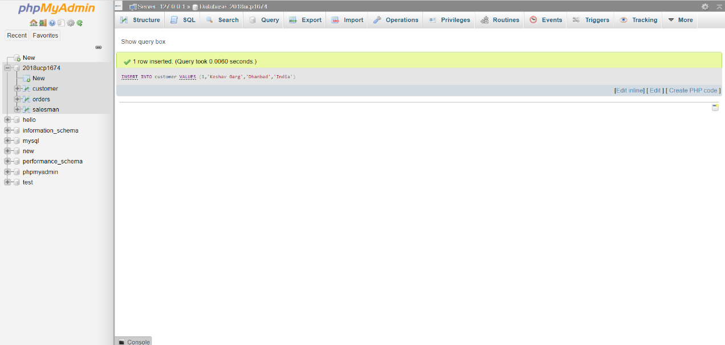

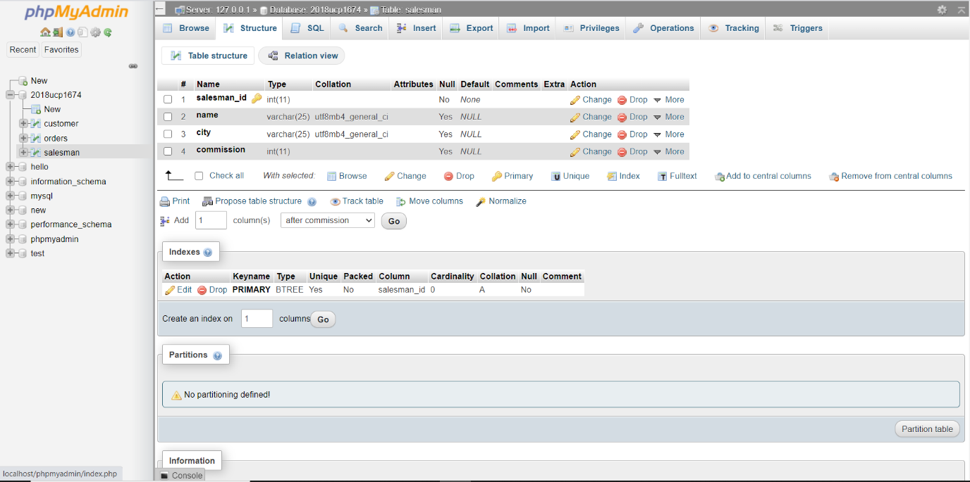

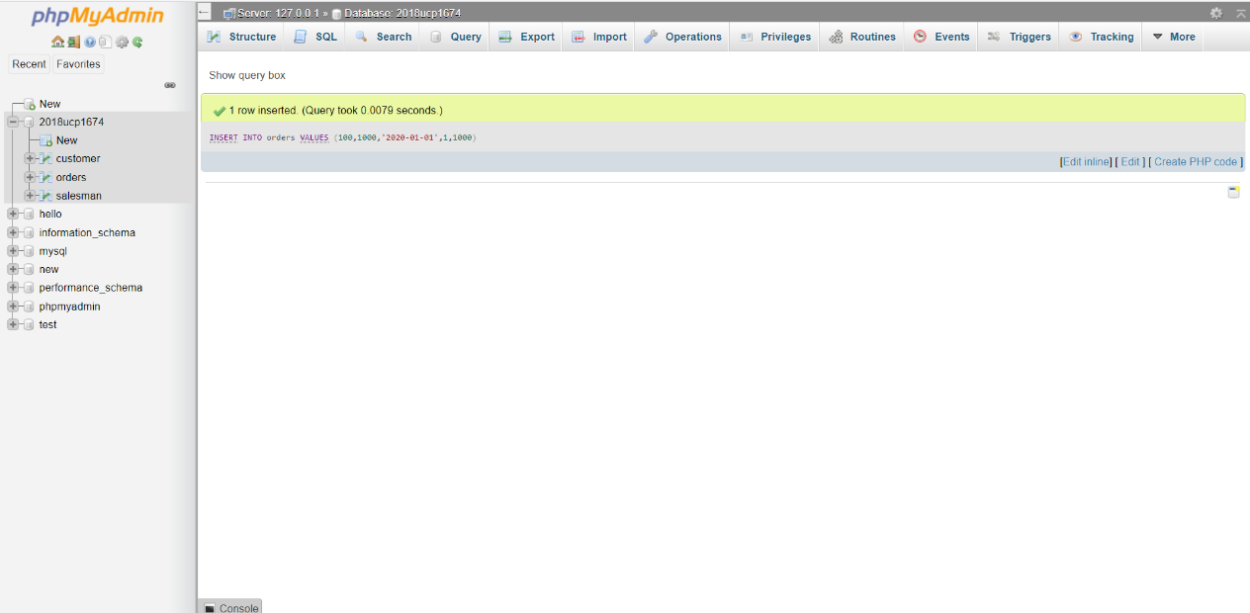

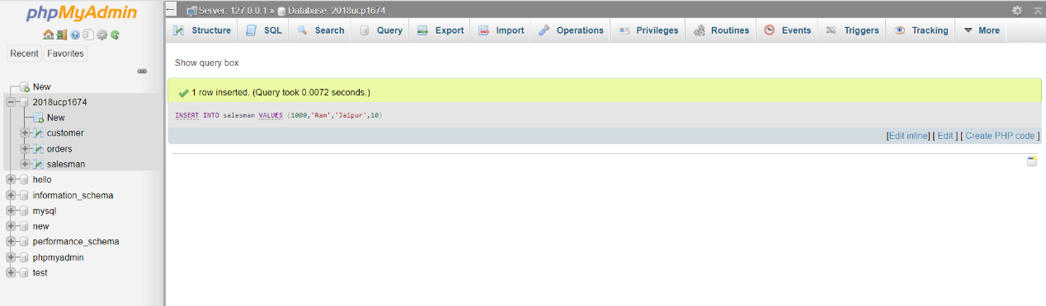

1. Insert multiple row of data in the table Customer, Orders & Salesman.

[INSERT](http://localhost/phpmyadmin/url.php?url=https://dev.mysql.com/doc/refman/5.5/en/insert.html) INTO salesman [VALUES](http://localhost/phpmyadmin/url.php?url=https://dev.mysql.com/doc/refman/5.5/en/miscellaneous-functions.html#function_values) (1001,'Shyam','Delhi',20), (1002,'Gita','Mumbai',30), (1003,'Lata','Pune',40);

[INSERT](http://localhost/phpmyadmin/url.php?url=https://dev.mysql.com/doc/refman/5.5/en/insert.html) INTO orders [VALUES](http://localhost/phpmyadmin/url.php?url=https://dev.mysql.com/doc/refman/5.5/en/miscellaneous-functions.html#function_values) (101,1001,'2020-01-02',2,1001), (102,5000,'2020-08-02',2,1003), (103,2500,'2020-07-10',1,1002);

[INSERT](http://localhost/phpmyadmin/url.php?url=https://dev.mysql.com/doc/refman/5.5/en/insert.html) INTO customer [VALUES](http://localhost/phpmyadmin/url.php?url=https://dev.mysql.com/doc/refman/5.5/en/miscellaneous-functions.html#function_values) (2,'Vaibhav','Nagda','India'), (3,'Abhinav','Moga','India'), (4,'Yashwant','Udaipur','India'), (5,'Yash','Bikaner','India');

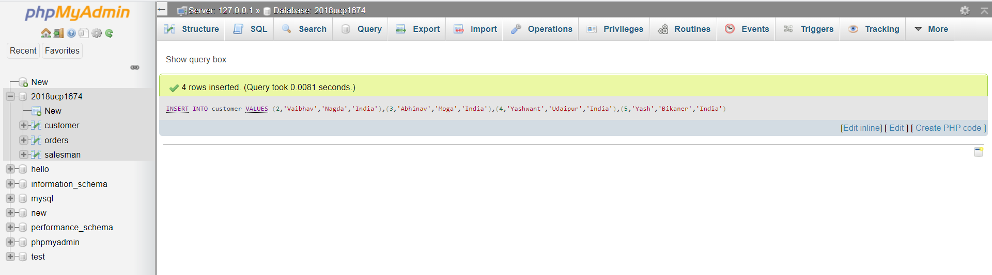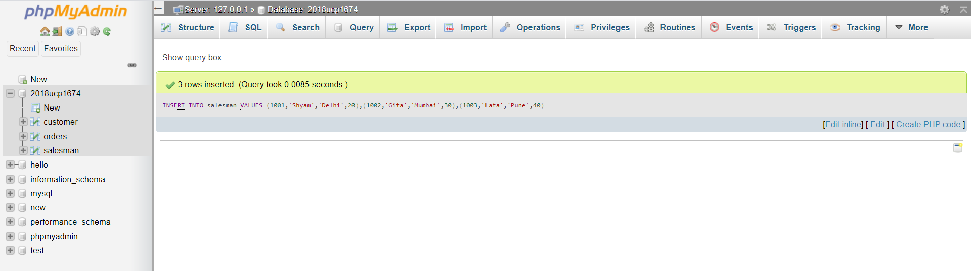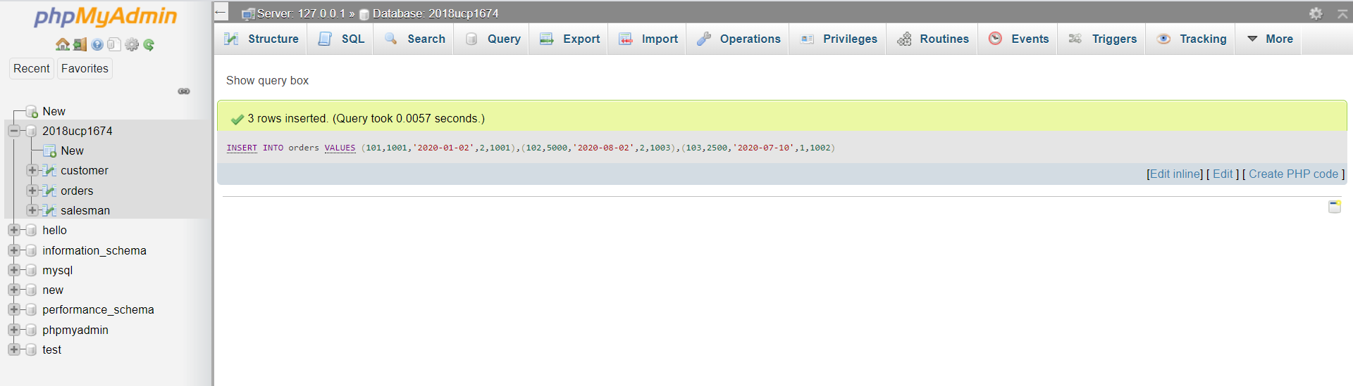

1. Write a query to list all customers with order amount greater than 1000 using subquery.

[SELECT](http://localhost/phpmyadmin/url.php?url=https://dev.mysql.com/doc/refman/5.5/en/select.html) \* from customer WHERE cust\_id [IN](http://localhost/phpmyadmin/url.php?url=https://dev.mysql.com/doc/refman/5.5/en/comparison-operators.html#function_in) ([SELECT](http://localhost/phpmyadmin/url.php?url=https://dev.mysql.com/doc/refman/5.5/en/select.html) cust\_id from orders where pur\_amt>=1000);

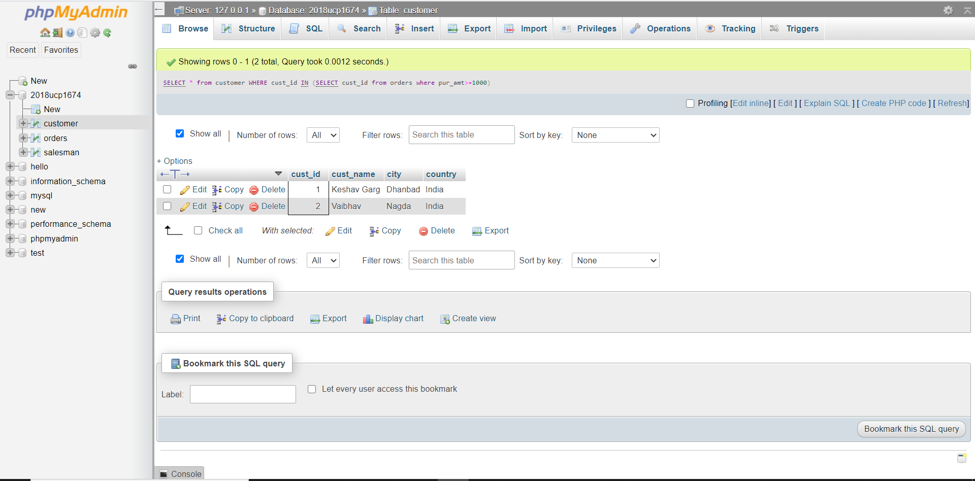

1. Write a query to list all customers with their total number of orders using subquery.

[SELECT](http://localhost/phpmyadmin/url.php?url=https://dev.mysql.com/doc/refman/5.5/en/select.html) \*, ([SELECT](http://localhost/phpmyadmin/url.php?url=https://dev.mysql.com/doc/refman/5.5/en/select.html) [count](http://localhost/phpmyadmin/url.php?url=https://dev.mysql.com/doc/refman/5.5/en/group-by-functions.html#function_count)(\*) from orders o where o.cust\_id=c.cust\_id) as CountOrders from customer c;

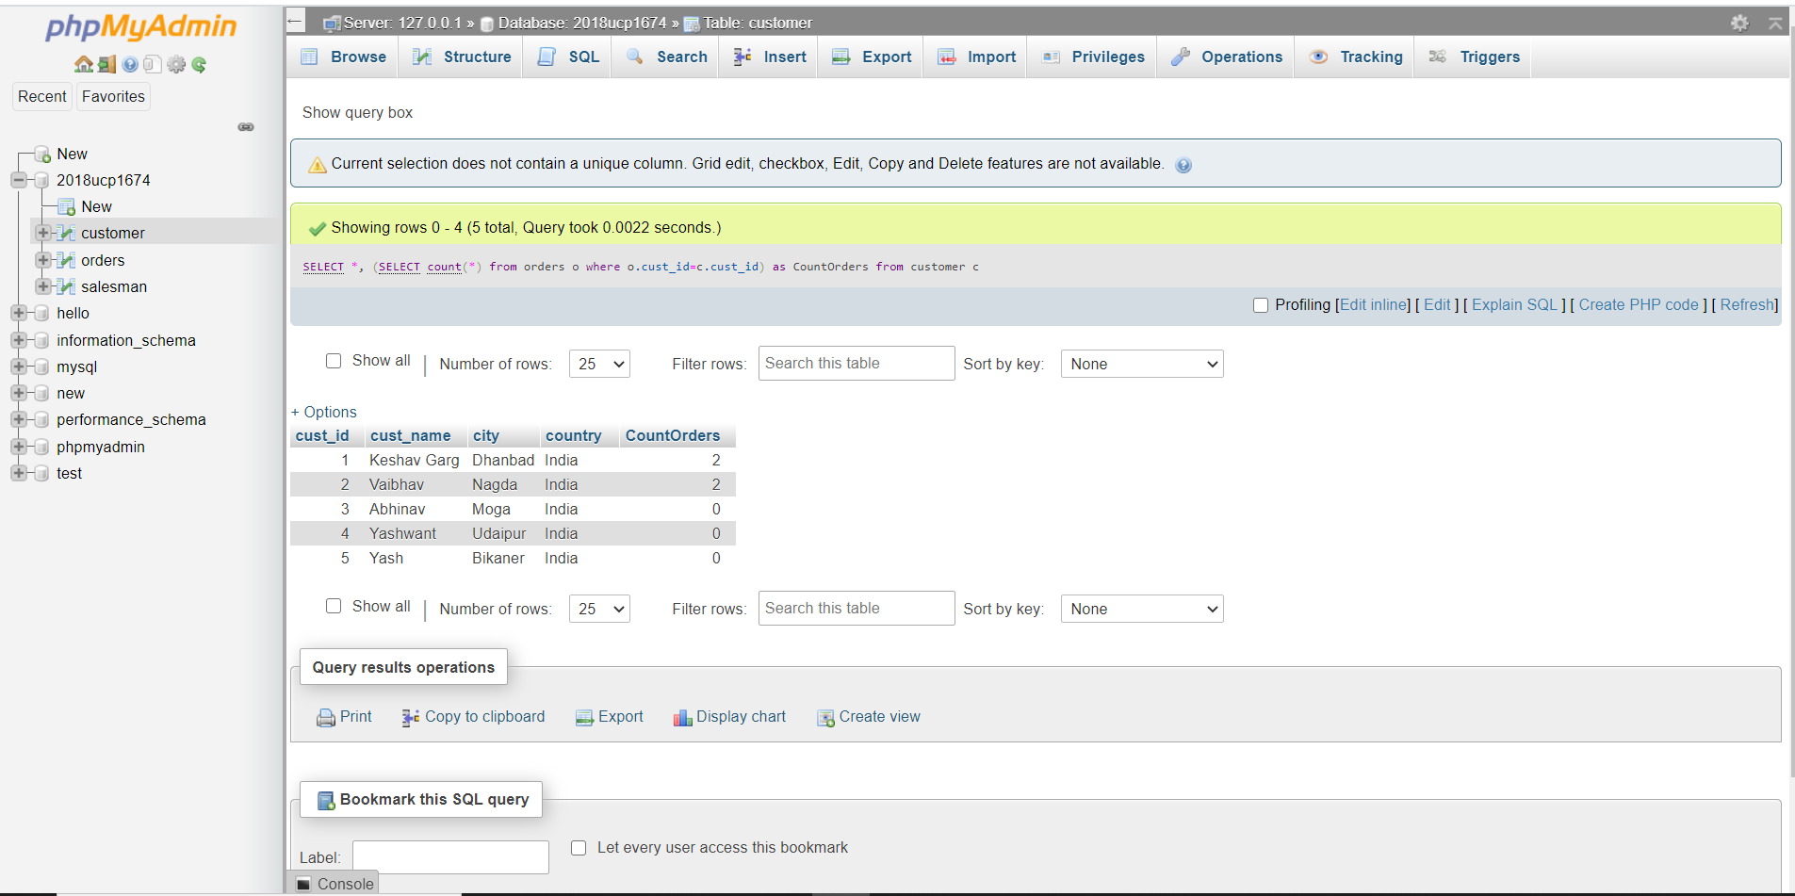

1. Write a query to find all the orders with order amounts which are above average amount for their customers using subquery

[SELECT](http://localhost/phpmyadmin/url.php?url=https://dev.mysql.com/doc/refman/5.5/en/select.html) \* FROM orders a WHERE pur\_amt > ([SELECT](http://localhost/phpmyadmin/url.php?url=https://dev.mysql.com/doc/refman/5.5/en/select.html) [AVG](http://localhost/phpmyadmin/url.php?url=https://dev.mysql.com/doc/refman/5.5/en/group-by-functions.html#function_avg)(pur\_amt) FROM orders b WHERE b.cust\_id = a.cust\_id);

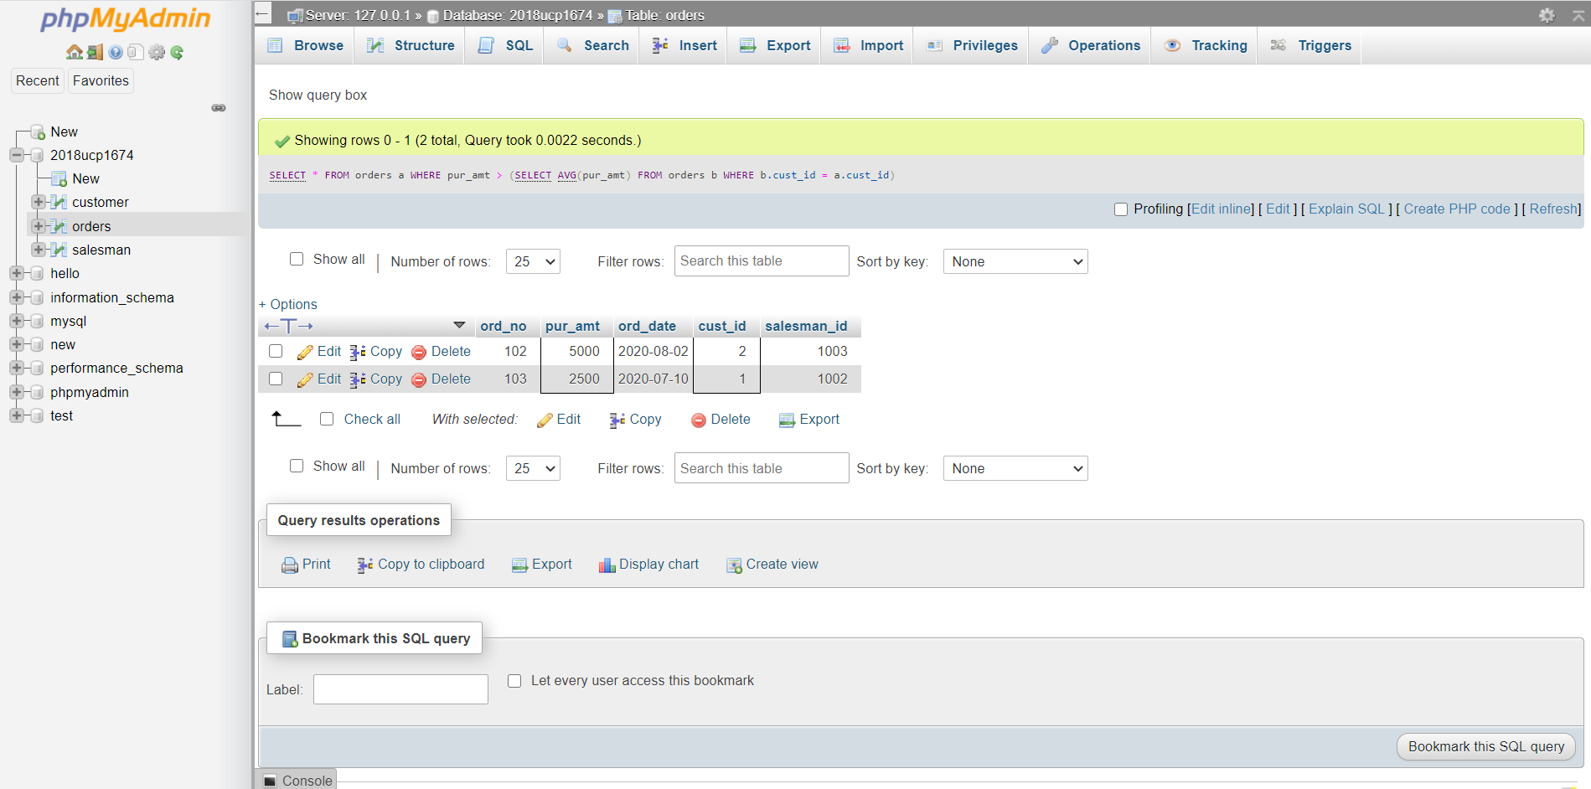

1. Given that you have a table named Customer in your database. Write a Create table statement to create another table Cust\_1 with same structure and data as that of

Customer.

[CREATE](http://localhost/phpmyadmin/url.php?url=https://dev.mysql.com/doc/refman/5.5/en/create-table.html) [TABLE](http://localhost/phpmyadmin/url.php?url=https://dev.mysql.com/doc/refman/5.5/en/create-table.html) cust\_1 as [SELECT](http://localhost/phpmyadmin/url.php?url=https://dev.mysql.com/doc/refman/5.5/en/select.html) \* from customer;

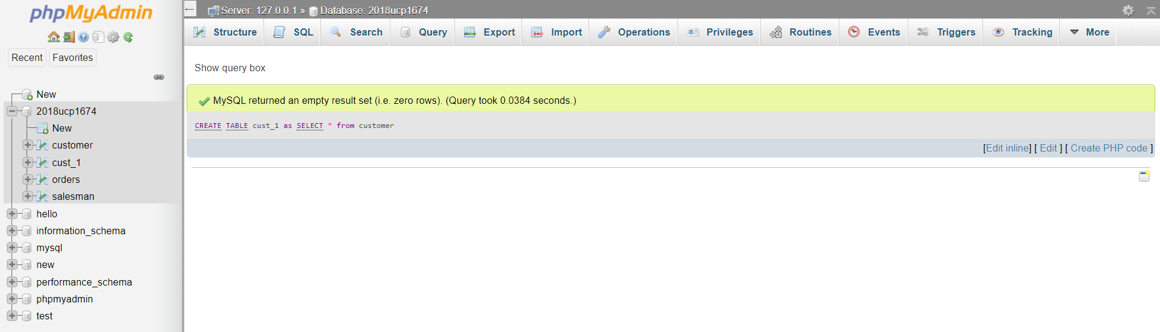

1. Given that you have a table named Customer in your database. Write a Create table statement to create another table Cust\_2 with same structure (but with no data) as that of Customer.

[CREATE](http://localhost/phpmyadmin/url.php?url=https://dev.mysql.com/doc/refman/5.5/en/create-table.html) [TABLE](http://localhost/phpmyadmin/url.php?url=https://dev.mysql.com/doc/refman/5.5/en/create-table.html) cust\_2 [LIKE](http://localhost/phpmyadmin/url.php?url=https://dev.mysql.com/doc/refman/5.5/en/string-comparison-functions.html#operator_like) customer;

